Famous typographers

Paragraph styles:
- Let you apply and globally update text formatting to speed up production
- Create a more consistent overall design
- Incorporate all elements of text formatting, including character attributes such as font, size, style, and colour, along with paragraph attributes such as indents, alignment, tabs, and hyphenation
- Differ from character styles in that they are applied to entire paragraphs at once, not just to selected characters.

Task - Watch the below tutorials
https://www.youtube.com/watch?v=O8zkpUy3uRM
https://www.youtube.com/watch?time_continue=9&v=3gW25FEVJlA

Then:
Pick one of the images below (or find your own) and recreate the layout using paragraph styles - the text and images can be different. You need to be using the appropriate paragraph styles e.g - heading, subheading, body text etc.

Image 1
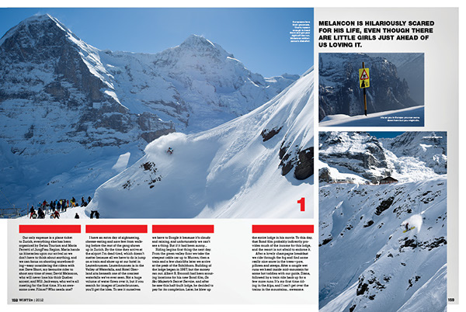
Snowboard Canada / Issue Four (vol 20)
Creator - Jeff Middleton CC BY-ND 4.0

Image 2

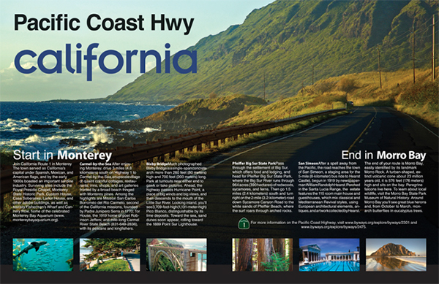
Magazine cover and spread
Creator - Kim Owens CC BY-ND 4.0

Image 3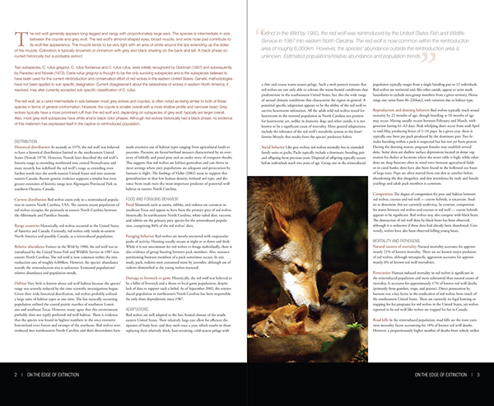
Red Wolves: On The Edge of Extinction Spreads
Creator - Diana Graham CC BY-ND 4.0

